**DAILY ONLINE ACTIVITIES SUMMARY**

|  |  |  |  |  |  |  |  |  |
| --- | --- | --- | --- | --- | --- | --- | --- | --- |
| **Date:** | **20-07-2020** | | | | | **Name:** | **Kanaka BS** | |
| **Sem & Sec** | **6th & A** | | | | | **USN:** | **4al17cs039** | |
| **Online Test Summary** | | | | | | | | |
| **Subject** | | **OS IA Module 4** | | | | | | |
| **Max. Marks** | | **30** | | **Score** | | | **-** | |
| **Certification Course Summary** | | | | | | | | |
| **Course** | HTML,CSS and JavaScript for Web Developers | | | | | | | |
| **Certificate Provider** | | | **Coursera** | | **Duration** | | | **5 Weeks** |
| **Coding Challenges** | | | | | | | | |
| **Problem Statement**: **Python Program for Maximum height when coins are arranged in a triangle** | | | | | | | | |
| **Status: Solved** | | | | | | | | |
| **Uploaded the report in Github** | | | | | **yes** | | | |
| **If yes Repository name** | | | | | <https://github.com/kanakabs/Daily-Status> | | | |
| **Uploaded the report in slack** | | | | | **yes** | | | |

**ONLINE COURSE**

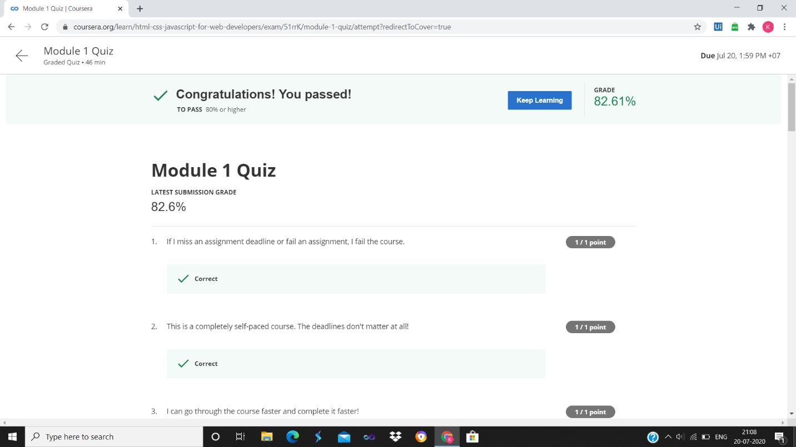

**ONLINE CODING**

**Python Program for Maximum height when coins are arranged in a triangle**

def squareRoot(n):

x = n

y = 1

e = 0.000001

while (x - y > e):

x = (x + y) / 2

y = n/x

return x

def findMaximumHeight(N):

n = 1 + 8*N

maxH = (-1 + squareRoot(n)) / 2

return int(maxH)

N = 12

print("Maximum Height is:\n",findMaximumHeight(N))

